KANE BROWN ANNOUNCES 35 CITY NORTH AMERICAN BLESSED & FREE TOUR
WITH A STOP IN MINNEAPOLIS, MN ON JANUARY 21ST AT TARGET CENTER

5X AMA Winner Brown Becomes First Country Artist
To Bring A Headlining Tour To All 29 NBA Arenas

Dates Include New York City’s Madison Square Garden, Brooklyn’s Barclays Center
and Los Angeles’ STAPLES Center Tickets

On Sale To General Public April 16.

New York, NY-April 8th, 2021— Today, Multi-Platinum, 5X AMA award-winning entertainer Kane Brown announced his headlining Blessed & Free Tour, stopping in 35 North American cities. The tour will visit the Target Center in Minneapolis, MN on January 21st. Brown made the announcement from the American Airlines Center in Dallas during one of his surprise promotional stops in upcoming tour markets. Starting October 1 in Sacramento, Brown’s Blessed & Free Tour will visit all 29 NBA basketball arenas throughout 2021 and 2022, making the “breakthrough entertainer” (AP) the first country artist in history to headline every NBA basketball arena in a single tour. A life-long basketball fan and former 4-sport high-school athlete, Brown first hinted at the tour during the 2020 NBA All-Star game in Chicago, where he played in the NBA celebrity All-Star game. The country star is set to visit milestone venues from coast-to-coast, including Brown’s first headlining dates at New York City’s Madison Square Garden and Brooklyn’s Barclays Center. Brown also returns to play the STAPLES Center in Los Angeles. Brown is among a handful of country artists in the arena’s 20-year history to sell-out the venue. In addition to the NBA arenas, Blessed & Free will make stops in Nampa, State College, Louisville, Pittsburgh, and Seattle at the brand new Climate Pledge Arena before wrapping the tour in Las Vegas. Chase Rice will join Brown for this date, as well as Restless Road, who Brown signed to his label, 1021 Entertainment.

Registration for Kane Brown’s pre-sale begins Thursday, April 8th at 10am CT at kanebrownlive.com. Tickets for Blessed & Free will go on-sale to the general public Friday, April 16th, at 10am local time. A limited number of VIP Packages will be available. These exclusive offers include an amazing selection of tickets, early-access to the General Admission Pit, limited edition merchandise and much more. Visit kanebrownmusic.com for a full list of tour dates, additional pre-sale and ticket on-sale information.

Noted as the “future of Country” (Billboard) and one of “31 People Changing the South” (Time), the chart-topping entertainer recently earned his first ACM Album of the Year nomination for Mixtape Vol. 1, as well as a Video of the Year nomination for his anthem “Worldwide Beautiful.” Brown first broke through the country charts with his #1 self-titled debut, which spent a record-breaking 13 weeks at the top of the chart and made Brown the first artist in Billboard history to Top all 5 Billboard Country charts simultaneously. Kane Brown earned three AMA Awards and produced two of the most streamed country songs of all time--the 7X platinum #1 hits “Heaven” and “What Ifs.” Brown’s sophomore album Experiment debuted #1 on the Billboard 200 all-genre chart and solidified Brown as the only male country artist in more than 24 years to debut at the top of the Billboard 200. Experiment produced back-to-back #1 hits and was ranked by The New York Times as one of the Top 10 Best Albums of the Year. His latest project, Mixtape Vol. 1 features Brown’s Top 10 pop radio hit “Be Like That” featuring Khalid and Swae Lee, his co-written duet “Last Time I Say Sorry” with John Legend, and his current hit at Country radio “Worship You.” Fueled by Marathon, Blessed & Free marks the first tour for Brown since his Worldwide Beautiful Tour, which earned critical praise during its international run.

Download Hi-Res Image Here
Photo Credit: Matthew Berinato

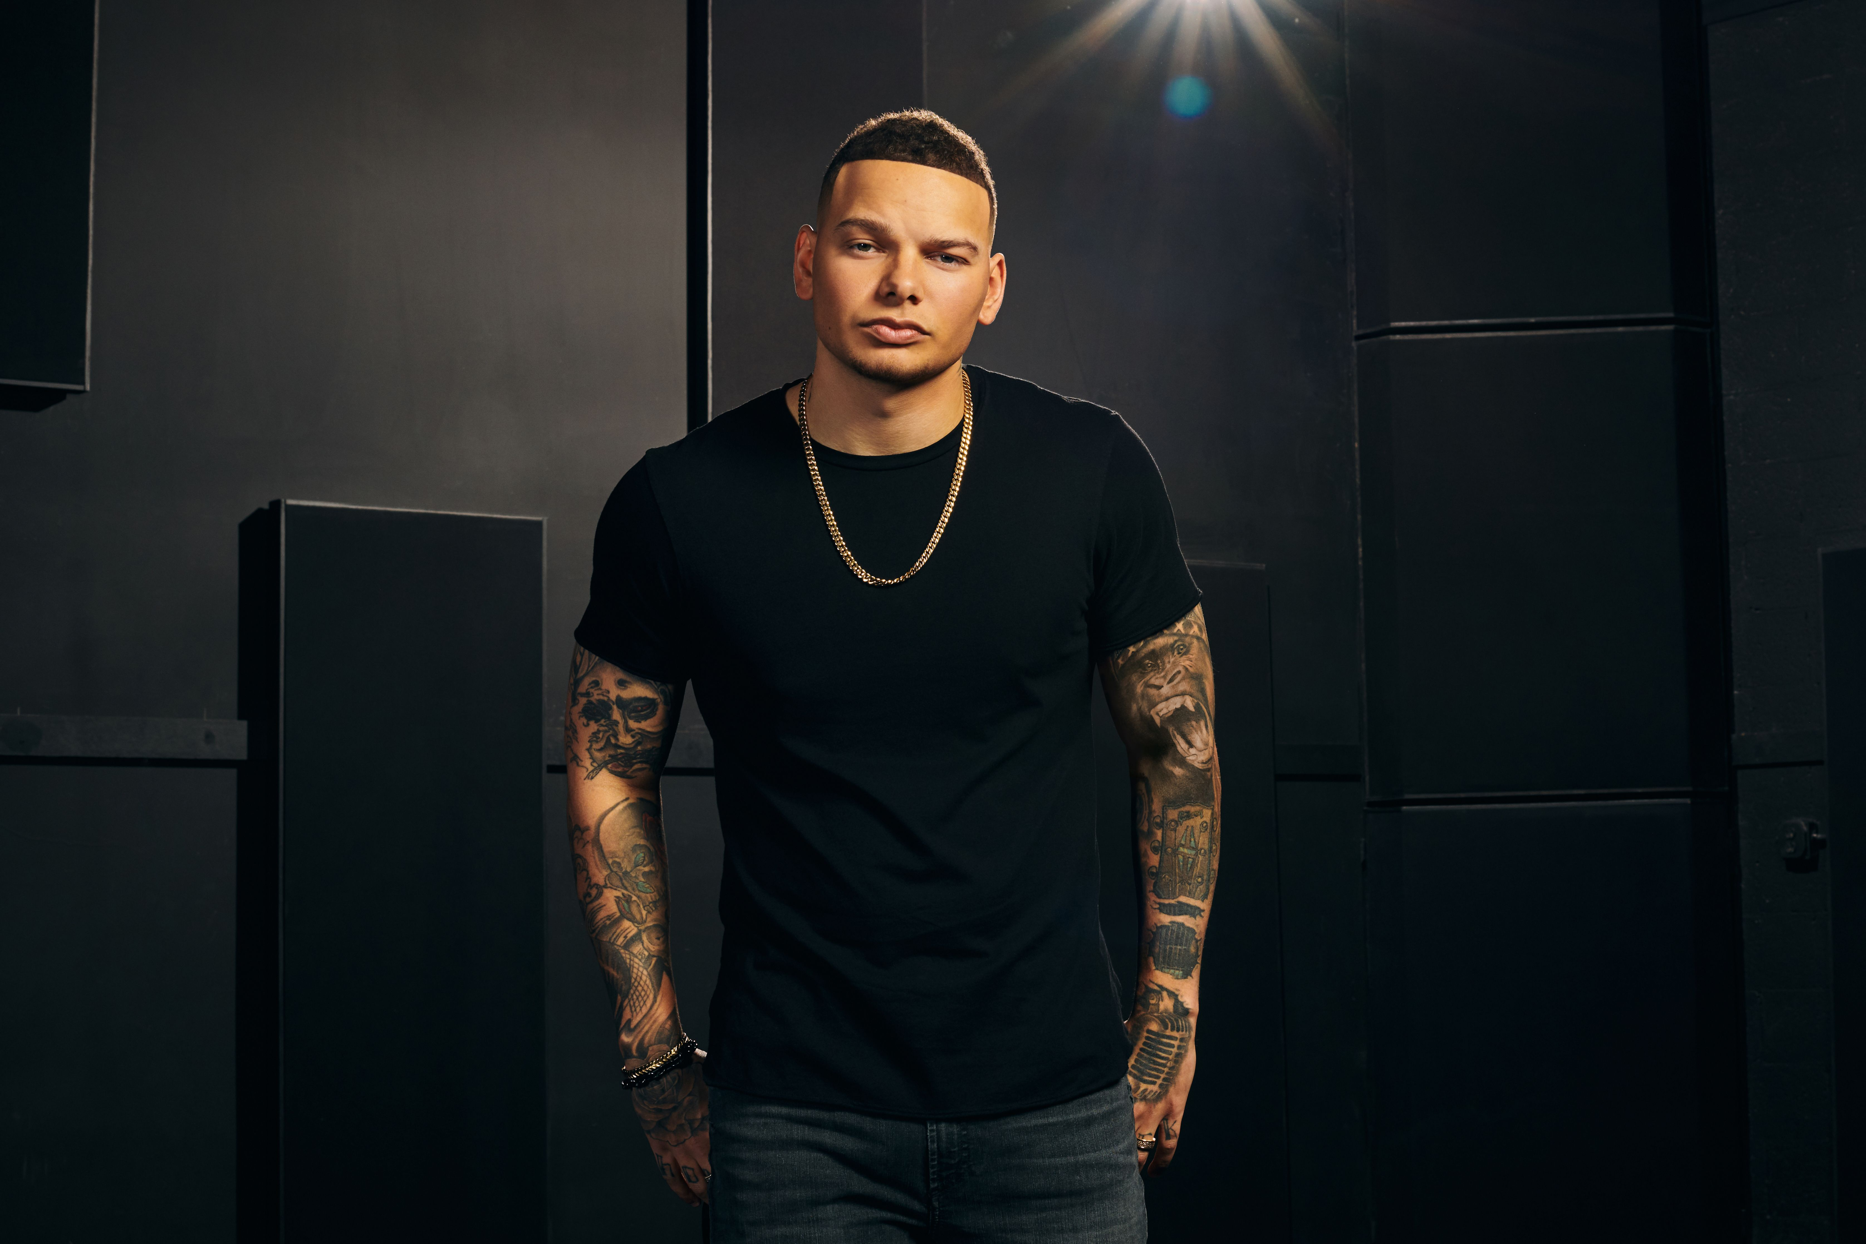

BLESSED & FREE TOUR DATES:

Friday, October 1, 2021 | Sacramento | Golden 1 Center
Saturday, October 2, 2021 | Los Angeles | STAPLES Center
Friday, October 8, 2021 | Nampa | Ford Idaho Center
Saturday, October 9, 2021 | Salt Lake City | Vivint Arena
Sunday, October 10, 2021 | Denver | Ball Arena
Thursday, October 14, 2021 | Oklahoma City | Chesapeake Energy Center
Friday, October 15, 2021 | Houston | Toyota Center
Saturday, October 16, 2021 | San Antonio | AT&T Center
Sunday, October 17, 2021 | Dallas | American Airlines Center
Friday, October 22, 2021 | New Orleans | Smoothie King Center
Saturday, October 23, 2021 | Memphis | FedExForum
Sunday, October 24, 2021 | Atlanta | State Farm Arena
Thursday, November 4, 2021 | Washington, D.C. | Capital One Arena
Friday, November 5, 2021 | Brooklyn | Barclays Center
Saturday, November 6, 2021 | State College | Bryce Jordan Center
Friday, November 19, 2021 | Toronto | Scotiabank Arena
Saturday, November 20, 2021 | Detroit | Little Caesars Arena
Sunday, November 21, 2021 | Cleveland | Rocket Mortgage Fieldhouse
Thursday, December 2, 2021 | Miami | AmericanAirlines Arena
Friday, December 3, 2021 | Orlando | Amway Center
Saturday, December 4, 2021 | Charlotte | Spectrum Center
Thursday, January 6, 2022 | Indianapolis | Bankers Life Fieldhouse
Friday, January 7, 2022 | Louisville | KFC Yum! Center
Saturday, January 8, 2022 | Pittsburgh | PPG Paints Arena
Thursday, January 13, 2022 | Philadelphia | Wells Fargo Center
Friday, January 14, 2022 | Boston | TD Garden
Saturday, January 15, 2022 | New York | Madison Square Garden
Thursday, January 20, 2022 | Milwaukee | Fiserv Forum
Friday, January 21, 2022 | Minneapolis | Target Center
Saturday, January 22, 2022 | Chicago | United Center
Thursday, January 27, 2022 | Portland | Moda Center
Friday, January 28, 2022 | Seattle | Climate Pledge Arena
Saturday, January 30, 2022 | San Francisco | Chase Center
Thursday, February 3, 2022 | Phoenix | Phoenix Suns Arena
Friday, February 4, 2022 | Las Vegas | T-Mobile Arena

About AEG Presents
Combining the power of the live event with a focus on true artist development, AEG Presents is a world leader in the music and entertainment industries. Operating across four continents, the company has an unparalleled commitment to artistry, creativity, and community. Its tentpole festivals and multi-day music events — which include the iconic Coachella Valley Music & Arts Festival and the legendary New Orleans Jazz & Heritage Festival alongside British Summer Time at Hyde Park, Stagecoach, All Points East, Hangout Festival, Electric Forest, and Firefly — continue to set the bar for the live music experience. AEG Presents promotes global tours for artists such as The Rolling Stones, Ed Sheeran, Elton John, Taylor Swift, Celine Dion, Justin Bieber, Kenny Chesney, Paul McCartney, Kane Brown, Carrie Underwood, Luke Combs, Dan + Shay and Katy Perry, in addition to — through its network of clubs, theatres, arenas, stadiums and renowned partner brands such as Goldenvoice, Messina Touring Group, Concerts West, The Bowery Presents, PromoWest Productions, Marshall Arts, Madison House Presents, and Zero Mile Presents — creating and developing an unmatched infrastructure for artist development and audience reach. More information can be found at www.aegpresents.com.

About Restless Road
Restless Road’s (Zach Beeken, Colton Pack and Garrett Nichols) self-titled debut EP Restless Road was released to critical acclaim and catapulted the country music trio into the National spotlight. Known for “harmonies that might make bands from the Eagles to the Jonas Brothers green with envy” and their “one-of-a-kind sound”(Pandora), the trio co-wrote three of the four songs on the EP and was later signed to Kane Brown’s label imprint, 1021 Entertainment. The multi-instrumentalists and impressive vocalists have been featured by NBC’s “Today,” Entertainment Weekly, Entertainment Tonight, People and more. The trio are returning to the stage after opening for The Worldwide Beautiful arena tour, where they played to a sold-out crowd at the Los Angeles STAPLES Center opening for Kane Brown. For more information about Restless Road visit https://www.restlessroad.com

About Chase Rice
With nearly 2 million albums sold and more than 1.7 billion total streams, plus a legion of passionate fans at his high-energy concerts across the globe, Chase Rice has established himself as a powerful force in Nashville and beyond – yet he genuinely sees current single “Drinkin’ Beer. Talkin’ God. Amen.” plus recent releases The Album Part I and The Album Part II as the launching pad for music that says what he wants to say, how he wants to say it. With songs such as Top 10 single “Lonely If You Are” featuring sleek rhymes over heartland six strings mixed with EDM-laced drama, this is the same gravely-voiced Chase Rice fans first fell in love with years ago – but better. Freer. Unbeholden and uninhibited, somehow capable of evoking Chris LeDoux and The Chronic, campfire singalongs and stadium anthems, all at once. The series follows his sophomore album, Lambs & Lions, released with Broken Bow Records in 2017 and featuring the Double-Platinum, two-week chart topper “Eyes On You” – Rice’s first No. 1 as an artist and the most-streamed song of his career. Lambs & Lions followed Ignite the Night, which debuted at No. 1 on Billboard’s Top Country Albums and No. 3 on the all-genre chart, producing a pair of Top 5 hits; “Ready Set Roll” and “Gonna Wanna Tonight.” In addition to supporting Kenny Chesney’s The Big Revival stadium tour, Rice has consistently sold out 2,500-3,000 seat venues on his own headlining tours.

Media Contacts

For Kane Brown:
Jennifer Vessio
1220 Entertainment
347-924-7001
Jennifer.g.vessio@gmail.com

For Blessed & Free Tour
Cara Hutchison
The Lede Company
cara.hutchison@ledecompany.com

